WEB PHISHING DETECTION PROJECT REPORT
Submitted By

HARINI B | 210819205011
JAYASRI S | 210819205017
HARINI D | 210819205012
SAFANA PARVEEN J | 210819205041

In partial fulfilment for the award of the degree Of

BACHELOR OF TECHNOLOGY
In



INFORMATION TECHNOLOGY
KINGS ENGINEERING COLLEGE, IRUNGATTUKOTAI ANNA UNIVERSITY: CHENNAI 600025

BONAFIDE CERTIFICATE

Certified that project report "Web Phishing Detection" is bonafide work of "HARINI B, JAYASRI S, HARINI D, SAFANA PARVEEN J" who carried out this project work under my supervision.

SIGNATURE SIGNATURE

Dr.G. MANIKANDAN Dr. J Briso Becky Bell

HEAD OF THE DEPARTMENT SUPERVISOR

Professor Assistant Professor

Dept of Information Technology, Dept of Information Technology

Kings Engineering College, Kings Engineering College,

Irungattukottai, Irungattukottai,

Chennai-602 117 Chennai-602 117.

ACKNOWLEDGEMENT

We thank God for his blessings and also for giving as good knowledge and strength in enabling us to finish our project. Our deep gratitude goes to our founder late Dr. D. SELVARAJ, M.A., M.Phil., for his patronage in the completion of our project. We like to take this opportunity to thank our honourable chairperson Dr.S. NALINI SELVARAJ, M.COM., MPhil., Ph.D. and honourable director, MR.S. AMIRTHARAJ, M.Tech., M.B.A for their support given to us to finish our project successfully. We wish to express our sincere thanks to our beloved principal. Dr.T.JOHN ORAL BASKAR., M.E., Ph.D for his kind encouragement and his interest towards us.

We are extremely grateful and thanks to our professor Dr.G.MANIKANDAN, head of Information Technology, Kings Engineering College, for his valuable suggestion, guidance and encouragement. We wish to express our sense of gratitude to our project supervisor Dr. J Briso Becky Bell, Assistant Professor of Information Technology Department, Kings Engineering College and project evaluator Dr.M Robinson Joel, Associate Professor of Information Technology Department, Kings Engineering College whose idea and direction made our project a grand success. We express our sincere thanks to our parents, friends and staff members who have helped and encouraged us during the entire course of completing this project work successfully.

TABLE OF THE CONTENT

 | CHAPTER | CONTENTS | PAGE NO
1 |  | INTRODUCTION
 |  | 1.1 PROJECT OVERVIEW | 1
 |  | 1.2 PURPOSE | 1
2 |  | LITERATURE SURVEY
 |  | 2.1 EXISTING PROBLEMS | 3
 |  | 2.2 REFERENCES | 3
3 |  | IDEATION AND PROPOSED SOLUTION
 |  | 3.1 EMPATHY MAP | 5
 |  | 3.2 IDEATION AND BRAINSTORMING | 6
 |  | 3.3 PROPOSED SOLUTION | 7
 |  | 3.4 PROBLEM SOLUTION FIT | 9

REQUIREMENT ANALYSIS

FUNCTIONAL REQUIREMENTS 10
NON-FUNCTIONAL REQUIREMENTS 11
PROJECT DESIGN
DATA FLOW DIAGRAMS 12
SOLUTION AND TECHNICAL ARCHITECTURE 13
USER STORIES 13
Application Characteristics 14
PROJECT PLANNING AND SCHEDULING
SPRINT PLANNING AND ESTIMATION 15
SPRINT DELIVERY SCHEDULE 16
REPORTS FROM JIRA 16
CODING AND SOLUTIONING
FEATURE 1: PREDICTION MODEL 17
FEATURE 2: DASHBOARD 24
FEATURE 3: LOGIN 26
FEATURE 4: SIGNUP 29
DATABASE SCHEMA 32
Training and Testing the Dataset 32
TESTING
TEST CASES 42
USER ACCEPTANCE TESTING 42
RESULTS
PERFORMANCE METRICS 43
ADVANTAGES AND DISADVANTAGES 43
CONCLUSION 44
FUTURE SCOPE 44
APPENDIX 44
APPENDIX A1– SCREENSHOTS 45

CHAPTER 1 INTRODUCTION:
: PROJECT OVERVIEW

The terms "heart disease" and "cardiovascular disease" are frequently used interchangeably. Heart disease is a general term that covers a wide range of heart related medical conditions. The irregular health state that directly affects the heart and all of its components is characterized by these medical conditions. In order to forecast cardiac disease, this study discusses various data mining, big data, and machine learning techniques. Building an important model for the medical system to forecast heart disease or cardiovascular illness requires the use of data mining and machine learning. Our application helps the user in finding out if they have heart disease or not. They can find out by entering details such as their heart rate, cholesterol, blood pressure etc. A dashboard is also attached along with the results for better understanding where they can compare their blood pressure and similar metrics with other users. This project focuses on Random Forest Classifier. The accuracy of our project is 87% for which is better than most other systems in terms of achieving accuracy quickly.
: PURPOSE

This project's goal is to determine, depending on the patient's medical characteristics—such as gender, age, chest pain, fasting blood sugar level, etc.— whether they are likely to be diagnosed with any cardiovascular heart illnesses. The leading cause of death in the developed world is heart disease. Heart disease cases are rising quickly every day, thus it's crucial and worrisome to predict any potential illnesses in advance. This diagnosis is a challenging task that requires accuracy and efficiency. Therefore, there needs to be work done to help prevent the risks of having a heart attack or stroke. It is the main factor in adult deaths. By using a person's medical history, our initiative can identify

those who are most likely to be diagnosed with a cardiac condition. It can assist in identifying disease with less medical tests and effective therapies, so that patients can be treated appropriately. It can identify anyone who is experiencing any heart disease symptoms, such as chest pain or high blood pressure. Around the world, machine learning is applied in many different fields. There is no exception in the healthcare sector. Machine learning may be crucial in determining whether locomotor disorders, heart illnesses, and other conditions are present or absent. If foreseen well in advance, such information can offer valuable insights to doctors, who can then customise their diagnosis and course of care for each patient.
The EHDPS predicts the likelihood of patients getting heart disease. It enables significant knowledge, eg, relationships between medical factors related to heart disease and patterns, to be established. We have employed the multilayer perceptron neural network with backpropagation as the training algorithm
.

CHAPTER 2 LITERATURE SURVEY
EXISTING PROBLEM

Phishing is a widespread method of tricking unsuspecting people into disclosing personal information by using fake websites. Phishing website URLs are designed to steal personal information such as user names, passwords, and online banking activities. Phishers employ webpages that are visually and semantically identical to legitimate websites. As technology advances, phishing strategies have become more sophisticated, necessitating the use of anti-phishing measures to identify phishing. Machine learning is an effective method for combating phishing assaults. This study examines the features utilised in detection as well as machine learning-based detection approaches. Phishing is popular among attackers because it is easier to persuade someone to click on a malicious link that appears to be legitimate than it is to break through a computer\'s protection measures. The malicious links in the message body are made to look like they go to the faked organisation by utilising the spoofed organization\'s logos and other valid material. We\'ll go through the characteristics of phishing domains (also known as fraudulent domains), the qualities that distinguish them from real domains, why it\'s crucial to detect them, and how they can be discovered using machine learning and natural language processing technique

CHAPTER 3

IDEATION & PROPOSED SOLUTION

EMPATHY MAP CANVAS

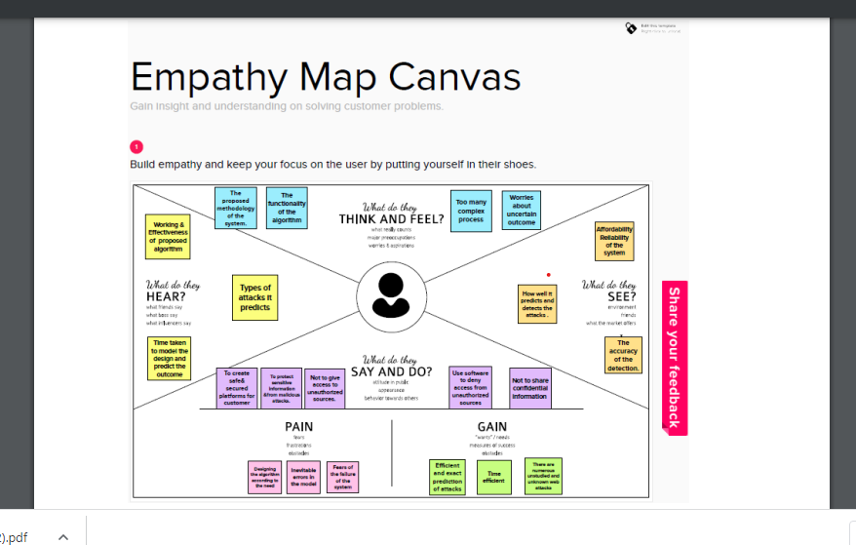
IDEATION & BRAINSTORMING

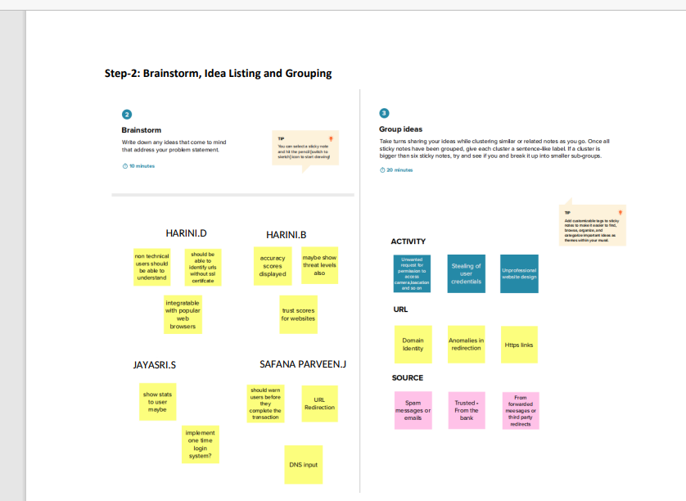

PROPOSED SOLUTION

Today's growing phishing websites pose significant threats due to their extremely undetectable risk. They anticipate internet users to mistake them as genuine ones in order to reveal user information and privacy, such as login ids, pass-words, credit card numbers, etc. without notice. This paper proposes a new approach to solve the anti-phishing problem. The new features of this approach can be represented by URL character sequence without phishing prior knowledge, various hyperlink information, and textual content of the webpage, which are combined and fed to train the XGBoost classifier. One of the major contributions of this paper is the selection of different new features, which are capable enough to detect 0-h attacks, and these features do not depend on any third-party services. In particular, we extract character level Term Frequency-Inverse Document Frequency (TF-IDF) features from noisy parts of HTML and plaintext of the given webpage. Moreover, our proposed hyperlink features determine the relationship between the content and the URL of a webpage. Due to the absence of publicly available large phishing data sets, we needed to create our own data set with 60,252 webpages to validate the proposed solution. This data contains 32,972 benign webpages and 27,280 phishing webpages. For evaluations, the performance of each category of the proposed feature set is evaluated, and various classification algorithms are employed. From the empirical results, it was observed that the proposed individual features are valuable for phishing detection.8 However, the integration of all the features improves the detection of phishing sites with significant accuracy. The proposed approach achieved an accuracy of --96.76% with only 1.39% false-positive rate on our dataset, and an accuracy of 98.48% with 2.09% false-positive rate on benchmark dataset, which outperforms the existing baseline approaches.

PROBLEM SOLUTION FIT

The Problem-Solution Fit simply means that we have found a problem with our customer and that the solution we have realized for it actually solves the customer’s problem. It helps entrepreneurs, marketers and corporate innovators identify behavioural patterns and recognize what would work and why. The purpose is to solve complex problems in a way that fits the state of your customers and succeed faster and increase your solution adoption by tapping into existing mediums and channels of behaviour

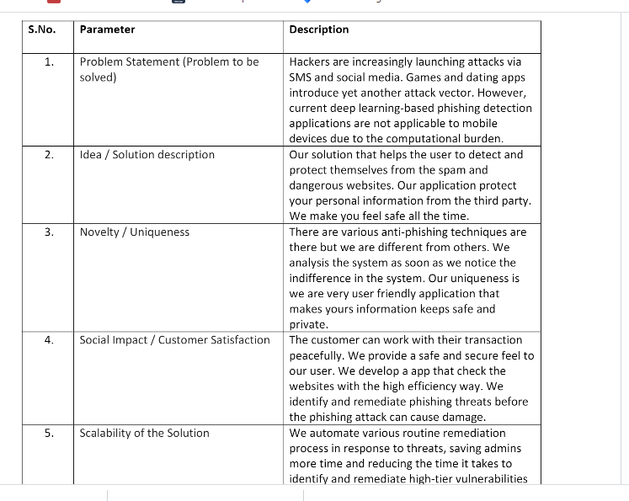
CHAPTER 4 REQUIREMENT ANALYSIS
FUNCTIONAL REQUIREMENTS

Using the IP address
Long URL to hide the Suspicious Part
Using URL shortening services TinyURL
URLs having @ symbol
Redirecting using //
Adding Prefix or Suffix Separated by (-) to the Domain.

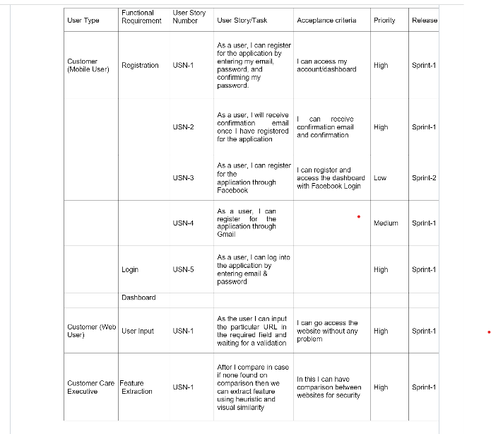
NON-FUNCTIONAL REQUIREMENTS

- Performance/Response time requirement This IDS photo gallery that we are developing will be used as the main performance system which interacts with members and administrators.
- Therefore, it is expected that the system would perform all the requirements that are specified.
- The system should be fast and accurate .
- System will handle expected and non-expected errors in a manner that will prevent information loss and long downtime period.
- System should have error testing to identify invalid username or password and email System should be able to handle large amounts of data System should accommodate high number of photos and users without any fault .
- Safety Requirement It has to be taken into account that at any given time the database may crash due to a virus or operating system failure.
- Therefore, it is required to take the database backup to prevent losing it. Appropriate UPS facility should be installed in case of power supply failure.
CHAPTER 5 PROJECT DESIGN
DATA FLOW DIAGRAMS

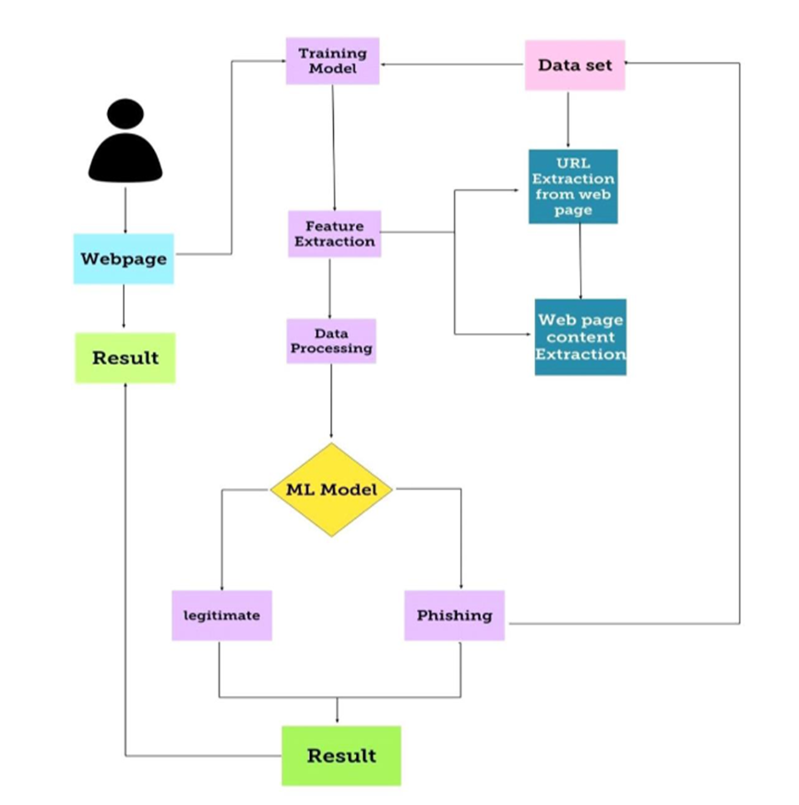

SOLUTION & TECHNICAL ARCHITECTURE
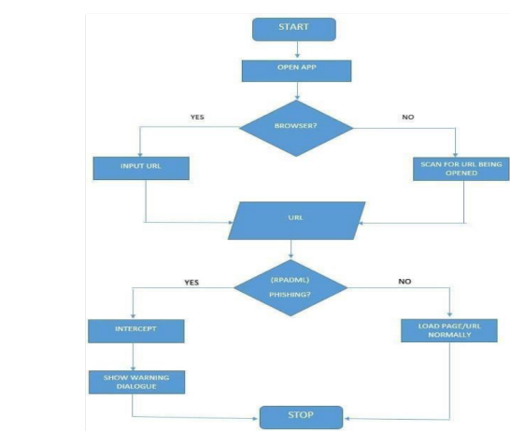

UseStories:

S.No | Component | Description | Technology
1. | Classification of phishing atttacks | Phishing websites are challenging to an organization. | Machine learning
2. | Phishing detection appproaches | Phishing detection schemes which detect phishing on the server side are better than phishing prevention. | Machine learning
3. | Normal dataset | It obtains the browsing habits of users from different sources | Machine Learning
4. | Phishing dataset | Phishtank is a familiar phishing website benchmark dataset | Machine Learning
5. | Testing data | Test data is data which has been specifically identified for use in tests, typically of a computer program. | Machine Learning
6. | Machine learning model | A machine learning model is a file that has been trained to recognize certain types of patterns. You train a model over a set of data, providing it an algorithm that it can use to reason over and learn from those data | Machine Learning.
7. | Improve model performance | Accuracy is one metric for evaluating classification  models. Informally, accuracy is the fraction of predictions our model got right. | Machine Learning
8. | Checking accuracy | A data accuracy check, sometimes called a data sanity check, is a set of quality validations that take place before using data. | Machine Learning

: Application Characteristics:
S.No | Characteristics | Description | Technology
1. | Collection of data | Data collection is the process of gathering, measuring, and analyzing accurate data from a variety of relevant sources to find answers to research problems, answer questions, evaluate outcomes, and forecast trends and probabilities | Machine Learning
2. | EDA Analysis | Exploratory Data Analysis (EDA) is an approach to analyze the data using visual techniques. It is used to discover trends, patterns, or to check assumptions with the help of statistical summary and graphical representations | Technology used
3. | Train & Test split of data | The train-test split is used to estimate the performance of machine learning algorithms that are applicable for prediction-based Algorithms/Applications. This method is a fast and easy procedure to perform such that we can compare our own machine learning model results to machine results. | Technology used

CHAPTER 6

PROJECT PLANNING & SCHEDULING

SPRINT PLANNING & ESTIMATION

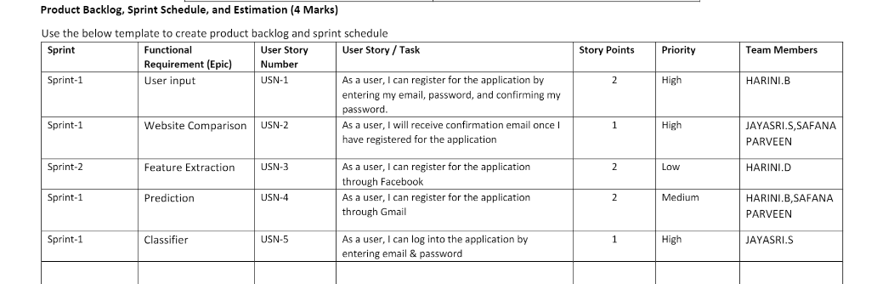

SPRINT DELIVERY SCHEDULE

Sprint | Total Story Points | Duration | Sprint Start Date | Sprint End Date (Planned) | Story Points Completed (as on Planned End  Date) | Sprint Release Date (Actual)
Sprint-1 | 1 | 3 Days | 24 Oct 2022 | 26 Oct 2022 | 1 | 26 Oct 2022
Sprint-2 | 1 | 3 Days | 31 Oct 2022 | 02 Nov 2022 | 1 | 02 Nov 2022
Sprint-3 | 1 | 3 Days | 07 Nov 2022 | 09 Nov 2022 | 1 | 09 Nov 2022
Sprint-4 | 1 | 3 Days | 14 Nov 2022 | 16 Nov 2022 | 1 | 16 Nov 2022

REPORTS FROM JIRA

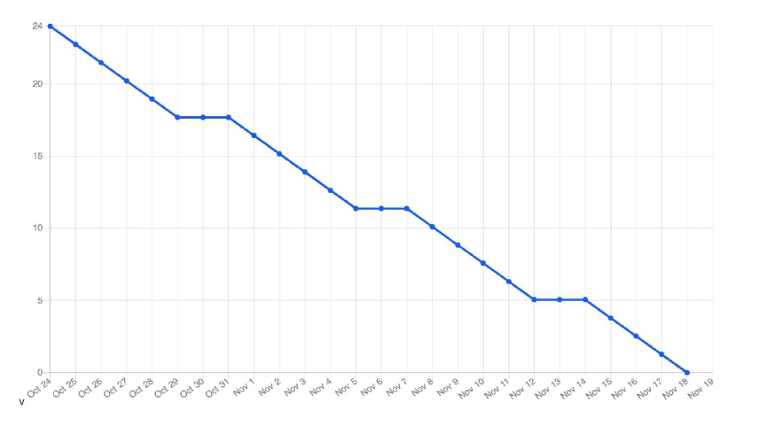
CHAPTER 7 CODING & SOLUTIONING
FEATURE 1

Prediction Model: When applied to a nonlinear data set, the random forest technique performs better than the decision tree. The collection of decision trees known as a random forest was produced by several root nodes. The random forest algorithm can achieve more accuracy quickly and produce expected results.
Algorithm:

Step 1: Input the required details

Step 2: The model processes the input with the help of random forest algorithm Step 3: The results are displayed

Code:

import axios from 'axios'; import React, { useState } from 'react'; import { useNavigate } from 'react-router- dom'; import './FormPageCommons.css'; function PredictionPage() { const [age, setAge] = useState(''); const [sex, setSex] = useState(''); const [chestPainType, setChestPainType] = useState(''); const [bp, setBp] = useState(''); const [cholesterol, setCholesterol] = useState(''); const [fbs, setFbs] = useState('');

const [ekg, setEkg] = useState(''); const [maxHr, setMaxHr] = useState(''); const [angina, setAngina] = useState(''); const [stDepression, setStDepression] = useState(''); const [slopeOfSt, setSlopeOfSt] = useState(''); const [fluro, setFluro] = useState(''); const [thallium, setThallium] = useState(''); const navigate = useNavigate(); function predictResult(event) { event.preventDefault(); if (age && sex && chestPainType && bp && cholesterol && fbs && ekg && maxHr && angina && stDepression && slopeOfSt && fluro && thallium) {
const predictionParams = {age,sex,chest_pain_type: chestPainType,bp,cholesterol,fbs_over_120: fbs, ekg_results: ekg,max_hr: maxHr,exercise_angina: angina, st_depression: stDepression,slope_of_st: slopeOfSt, number_of_vessels_fluro: fluro, thallium,}; const headers = {
Authorization: `Bearer ${sessionStorage.getItem('token')}`,

};

axios.post('http://127.0.0.1:8000/predict', predictionParams, { headers })

.then((response) => { predictionParams.prediction

= response.data.prediction;

[predictionParams.date, predictionParams.time] = new Date().toLocaleString().split(', '); sessionStorage.setItem('prediction', JSON.stringify(predictionParams)); navigate('/results');
}) // eslint-disable-line no-console

.catch((ex) => console.log(ex)); // eslint-disable-line no-console

} }

return (

<div className="main-container">

<form className="main-form" onSubmit={predictResult}>

<div className="title">Enter your details</div>

<div className="form-input">

<p>Age</p>

<input type="number" name="Age" id="text-input" value={age} onChange={(e) => setAge(e.target.value)} />
</div>

<div className="form-input">

<p>Sex</p> <select name="sex" id="sel-input"
value={sex} onChange={(e) => setSex(e.target.value)}
>

<option value="-1">--Select Value--</option>

<option value="1">Male</option>

<option value="0">Female</option>

</select>

</div>

<div className="form-input">

<p>Chest Pain Type</p>

<select name="chest-pain" id="sel- input" value={chestPainType}
onChange={(e) => setChestPainType(e.target.value)}

>

<option value="-1">--Select Value--</option>

<option value="1">Typical Angina</option>

<option value="2">Atypical Angina</option>

<option value="3">Non Anginal Pain</option>

<option value="4">Asymptomatic Pain</option>

</select>

</div>

<div className="form-input">

<p>Blood Pressure</p>

<input type="number" className="form field" name="bp" id="text-input" value={bp} onChange={(e) => setBp(e.target.value)} />
</div>

<div className="form-input">

<p>Cholesterol</p>

<input type="number" name="cholesterol" id="text-input" value={cholesterol} onChange={(e) => setCholesterol(e.target.value)} />

</div>

<div className="form-input">

<p>Fasting Blood Sugar Over 120</p>

<select name="fbs" id="sel- input" value={fbs}
onChange={(e) => setFbs(e.target.value)}

>

<option value="-1">--Select Value--</option>

<option value="1">Yes</option>

<option value="0">No</option>

</select>

</div>

<div className="form-input">

<p>EKG Results</p>

<select name="ekg" id="sel- input" value={ekg}
onChange={(e) => setEkg(e.target.value)}

>

<option value="-1">--Select Value--</option>

<option value="0">Normal</option>

<option value="1">Having ST-T wave abnormality (T wave inversions and/or ST elevation or depression of greater than 0.05 mV)</option>
<option value="2">Showing probable or definite left ventricular hypertrophy by Estes`'` criteria</option>
</select>

</div>

<div className="form-input">

<p>Maximum Heart Rate</p>

<input type="number" name="mhr" id="text-input" value={maxHr} onChange={(e)
=> setMaxHr(e.target.value)} />

</div>

<div className="form-input">

<p>Exercise Induced Angina</p>

<select name="angina" id="sel- input" value={angina}
onChange={(e) => setAngina(e.target.value)}

>

<option value="-1">--Select Value--</option>

<option value="1">Yes</option>

<option value="0">No</option>

</select>

</div>

<div className="form-input">

<p>ST Depression</p>

<input type="number" name="stdep" id="text-input" value={stDepression} onChange={(e) => setStDepression(e.target.value)} />
</div>

<div className="form-input">

<p>Slope of ST</p>

<select name="slope-st" id="sel- input" value={slopeOfSt}
onChange={(e) => setSlopeOfSt(e.target.value)}

>

<option value="-1">--Select Value--</option>

<option value="1">Upsloping</option>

<option value="2">Flat</option>

<option value="3">Downsloping</option>

</select>

</div>

<div className="form-input">

<p>Number of major vessels colored by Flouroscopy</p>

<select name="fluro" id="sel- input" value={fluro}
onChange={(e) => setFluro(e.target.value)}

>

<option value="-1">--Select Value--</option>

<option value="0">0</option>

<option value="1">1</option>

<option value="2">2</option>

<option value="3">3</option>

</select>

</div>

<div className="form-input">

<p>Thallium</p>

<select name="thallium" id="sel- input" value={thallium}
onChange={(e) => setThallium(e.target.value)}

>

<option value="-1">--Select Value--</option>

<option value="3">Normal</option>

<option value="6">Fixed Defect</option>

<option value="7">Reversable Defect</option>

</select>

</div>

<button type="text" className="submit">Submit</button>

</form>

</div>

);

} export default PredictionPage;

FEATURE 2

Dashboard: Our application helps the user in finding out if they have heart disease or not. They can find out by entering details such as their heart rate, cholesterol, blood pressure etc. A dashboard is also attached along with the results for better understanding where they can compare their blood pressure and similar metrics with other users.
Code:

import Sidebar from "../../components/sidebar/Sidebar" import "./home.scss" import "./Cards.css" const DashboardHome = () => {
return (

<div className="home">

<Sidebar />

<div className="homeContainer">

<h1>Welcome to your Dashboard!</h1>

<br />

<br />

<br />

<h3>Check out your email. Your results have been sent there.</h3>

<br />

<br />

<h3>Here you can check out different kind of visualizations to get a general idea about the factors increasing causes of getting a cardiac arrest.</h3>
<br />

<div class="row">

<div class="col-md-4 col-xl-3">

<div class="card bg-c-blue order-card">

<div class="card-block">

<h2 class="text-right"><i class="fa fa-cart-plus fleft"></i><span>87%</span></h2>
<p class="m-b-0">Accuracy</p>

</div>

</div>

</div>

<div class="col-md-4 col-xl-3">

<div class="card bg-c-green order-card">

<div class="card-block">

<h2 class="text-right"><i class="fa fa-cart-plus f-left"></i><span>5</span></h2>

<p class="m-b-0">Visualization Types</p>

</div>

</div>

</div>

<div class="col-md-4 col-xl-3">

<div class="card bg-c-yellow order-card">

<div class="card-block">

<h2 class="text-right"><i class="fa fa-cart-plus f-left"></i><span>Random Forest Classifier</span></h2>
<p class="m-b-0">ML Model</p>

</div>

</div>

</div>

</div>

</div>

</div>

)

} export default DashboardHome

FEATURE 3 Login Algorithm:
- Input the credentials (email and password).

- If already logged in user is taken to home page

- Else, check for validity of credentials

- If wrong credentials entered , notification is displayed to user and user stays in login page.
- On correct credentials, user is taken to home page.

Code:

import axios from 'axios'; import React, { useState } from 'react'; import './FormPageCommons.css'; import { useNavigate } from 'react-router-dom'; const Login = () => { const [email, setEmail] = useState(''); const [password, setPassword] = useState(''); const navigate = useNavigate(); function loginUser(event) { event.preventDefault(); const userDetails = { email, password,
};

// console.log(userDetails); // eslint-disable-line no-console if (userDetails && userDetails.email && userDetails.password) { axios.post('http://127.0.0.1:8000/login', userDetails)
.then((response) => { sessionStorage.setItem('token', response.data.token); navigate('/predict');
})

.catch((ex) => {

// console.log(ex); // eslint-disable-line no-console

// const error = JSON.parse(ex);

if (ex.response && ex.response.status && ex.response.status === 404) { alert('User not found'); // eslint-disable-line no-alert

} else { console.log(ex); // eslint-disable- line no-console
}

});

} else { alert('Please enter valid credentials'); // eslint-disable- line no-alert } } return (
<div className="main-container">

<form className="main-form" onSubmit={loginUser}>

<div className="form-input">

<p>e-mail</p>

<input type="email" name="email" id="email" value={email} onChange={(e) => setEmail(e.target.value)} />
</div>

<div className="form-input">

<p>Password</p>

<input type="password" name="password" id="password" value={password} onChange={(e) => setPassword(e.target.value)} />
</div>

<div className="button-container">

<input type="submit" />

</div>

</form>

</div>

); }; export default Login;

FEATURE 4:

Signup Algorithm:
- Input the signup form fields (name , email , password , re-enter password).

- All credentials are validated.

- Website checks whether the given email exists in the database.

- If already registered, notification is displayed. Or else, the user is taken to the login page.

Code:

import axios from 'axios'; import React, { useState } from 'react'; import { useNavigate } from 'react-router-dom'; import { Link } from 'react-router-dom'; const Register = () => { const [name, setName] = useState('');

const [email, setEmail] = useState(''); const [password, setPassword] = useState(''); const [confPassword, setConfPassword] = useState(''); const navigate = useNavigate(); function registerUser(event) { event.preventDefault();
const userDetails = { fullName: name, email, password,

};

if (userDetails && userDetails.fullName && userDetails.password && userDetails.email)
{

// console.log('Hi'); // eslint-disable-line no-console axios.post('http://127.0.0.1:8000/register', userDetails)
.then(() => {

// console.log(response.json); // eslint-disable-line no-console navigate('/login');
})

.catch((ex) => console.log(ex)); // eslint-disable-line no-console

} }

return (

<div className="main-container">

<form className="login-form" onSubmit={registerUser}>

<div className="form-input">

<p>Name</p>

<input type="text" name="text" id="text" value={name} onChange={(e) => setName(e.target.value)} />
</div>

<div className="form-input">

<p>e-mail</p>

<input type="email" name="email" id="email" value={email} onChange={(e) => setEmail(e.target.value)} />
</div>

<div className="form-input">

<p>Password</p>

<input type="password" name="password" id="password" value={password} onChange={(e) => setPassword(e.target.value)} />
</div>

<div className="form-input">

<p>Confirm Password</p>

<input type="password" name="password" id="conf-password" value={confPassword} onChange={(e) => setConfPassword(e.target.value)} />
</div>

<div className="button-container">

<input type="submit" />

<p>Already have an account?</p>

<Link to="/login">

<button type="button">Login</button>

</Link>

</div>

</form>

</div>

); }; export default Register;

DATABASE SCHEMA

NoSQL databases like MongoDB offer high performance, high availability, and easy scalability. MongoDB is a documentoriented database which stores data in JSON-like documents with dynamic schema. It means you can store your records without worrying about the data structure such as the number of fields or types of fields to store values. MongoDB documents are similar to JSON objects. Details like name, e-mail, password of the registered user are stored so that when the user tries to login, authentication takes place and the user is logged in.
Training and Testing the Dataset
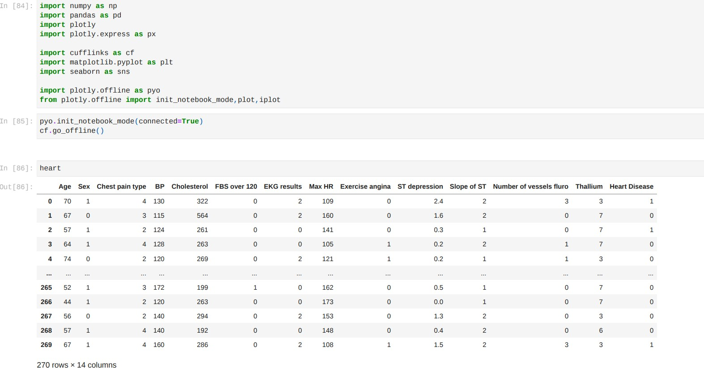

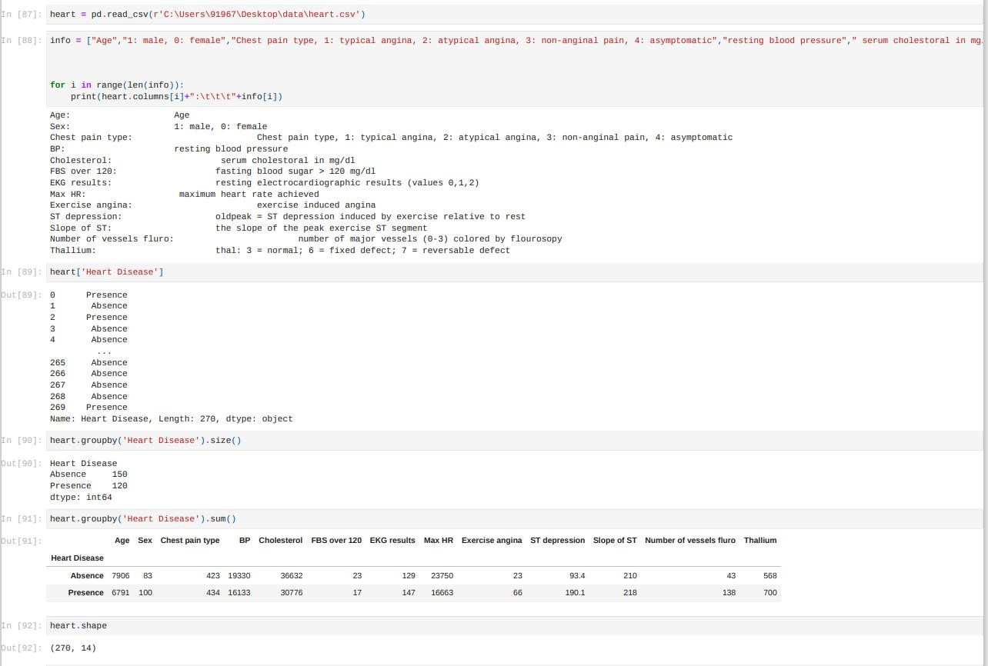
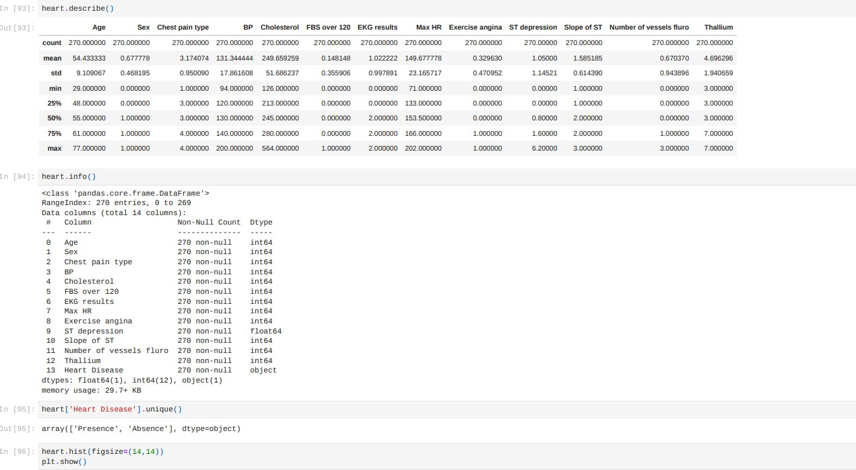

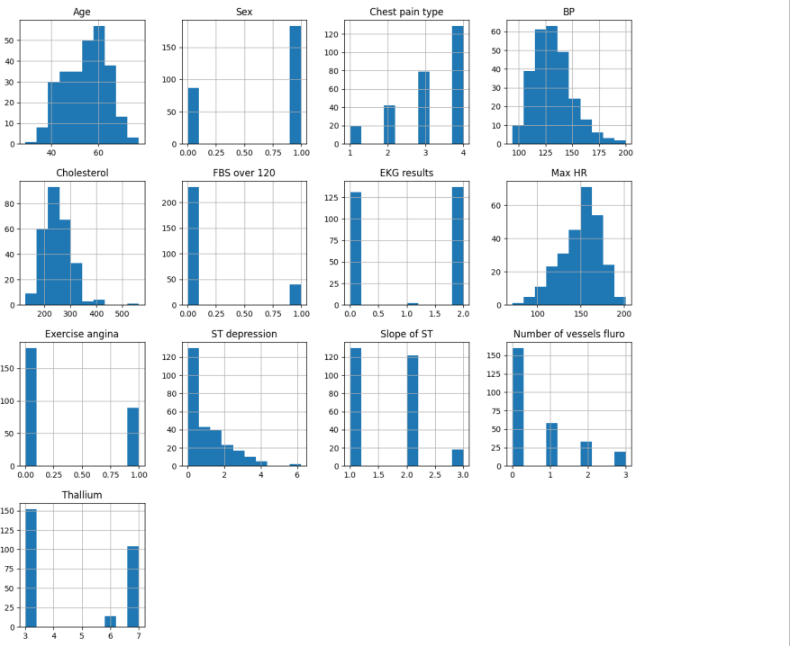

x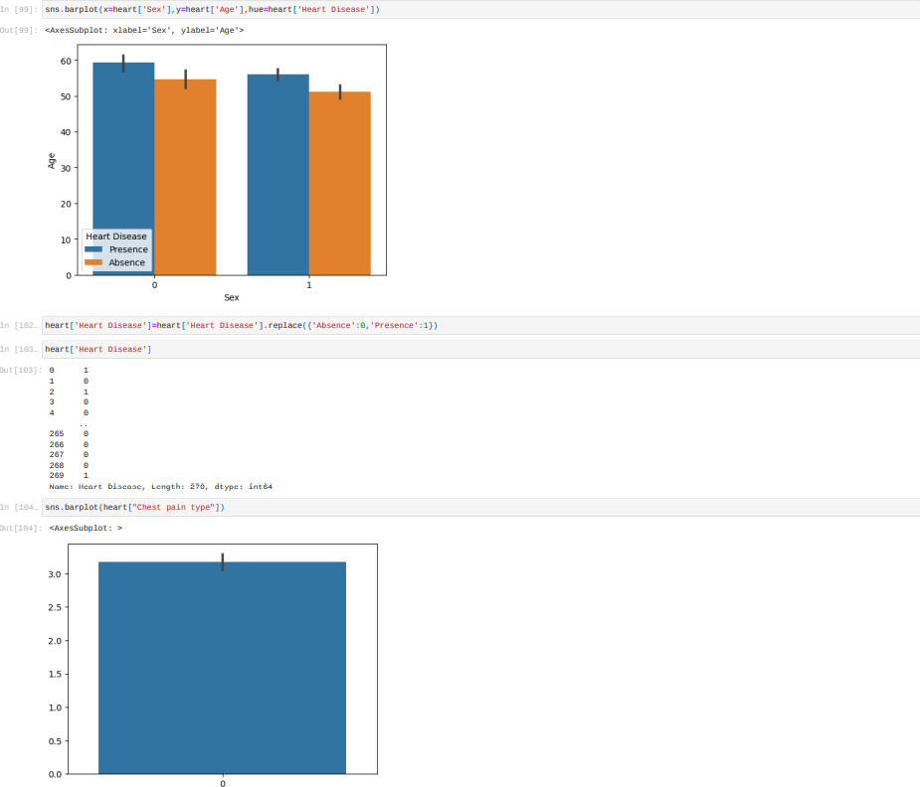
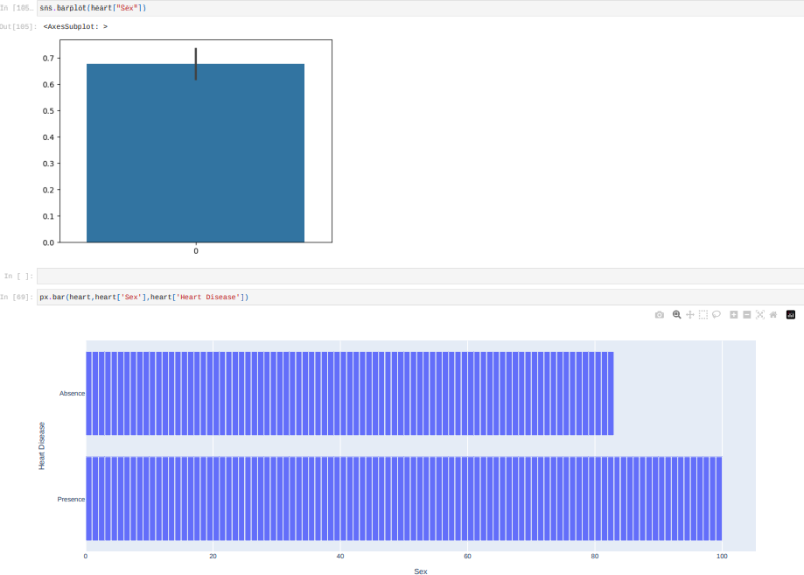

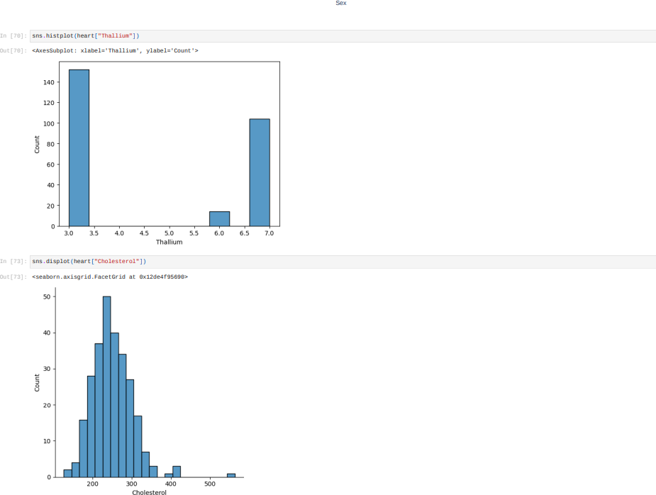

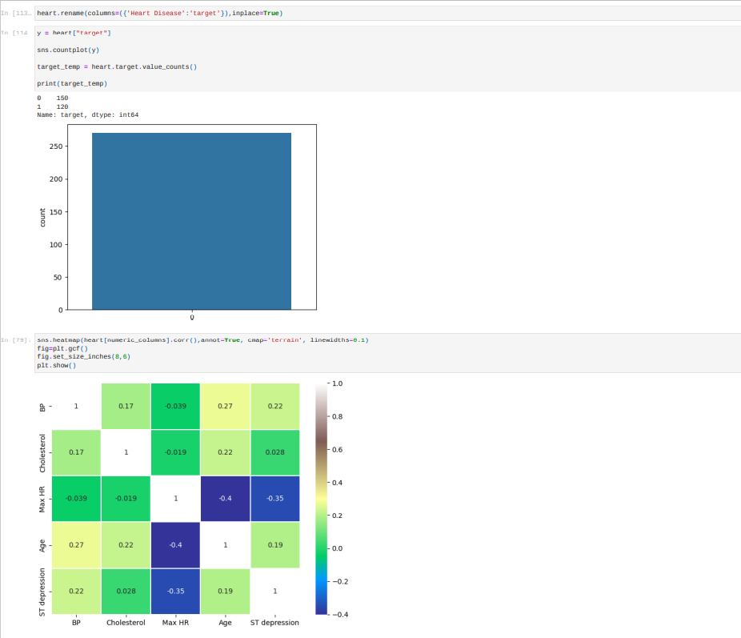

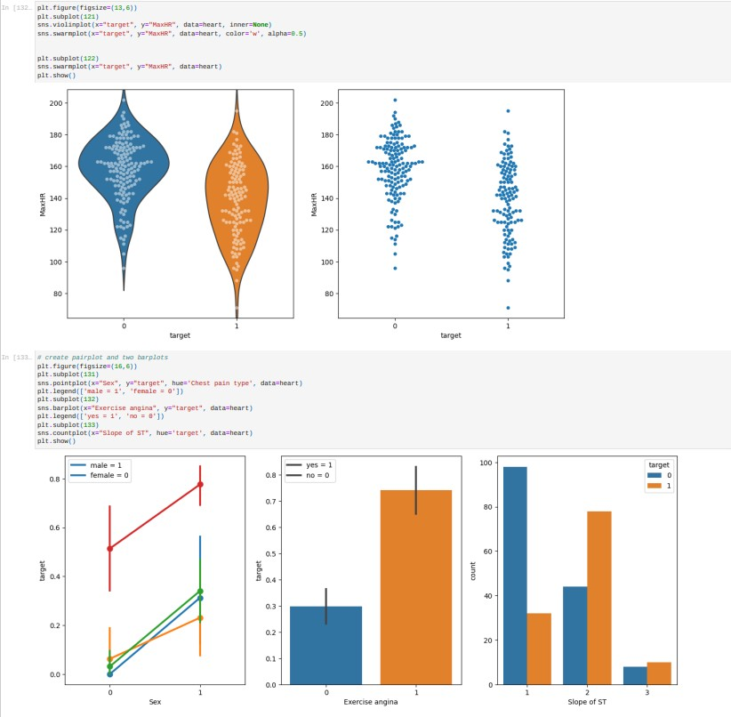

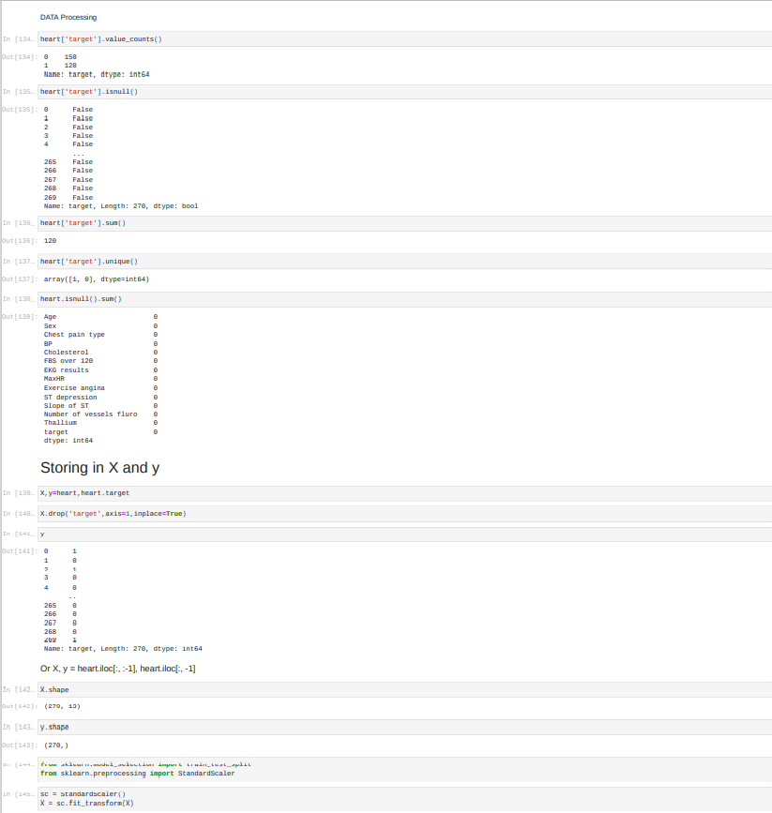

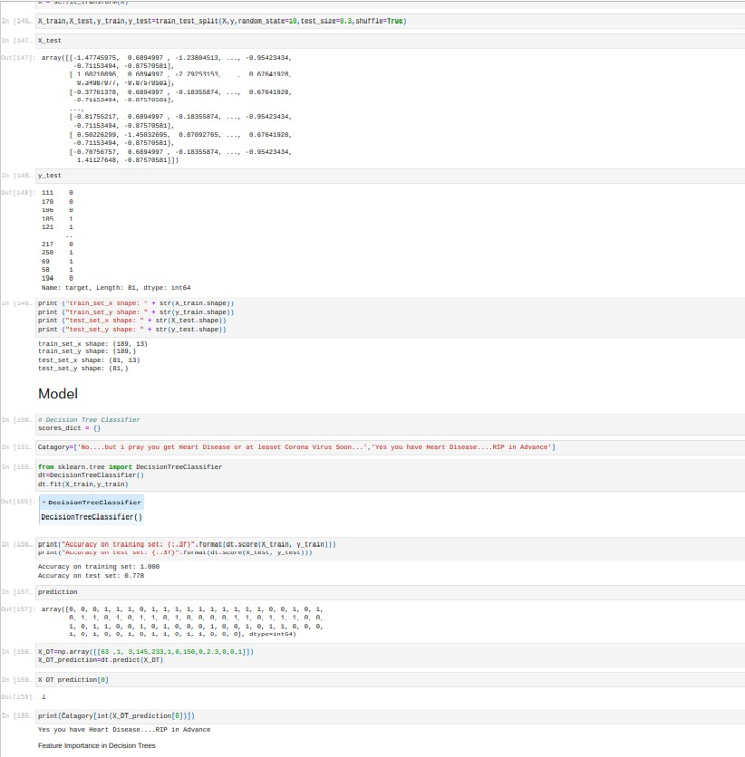

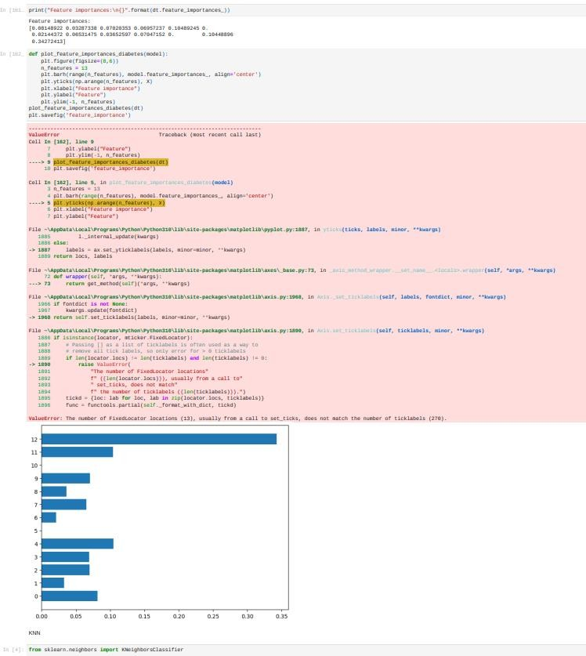

CHAPTER 8 TESTING
TEST CASES

Testcase 1: Logging in with registered login details.

Testcase 2: Logging in with invalid login details.

Testcase 3: Registering with existing user’s details.

Testcase 4: Entering wrong values while filling medical related details.

Testcase 5: Producing visualisations for given input.

USER ACCEPTANCE TESTING

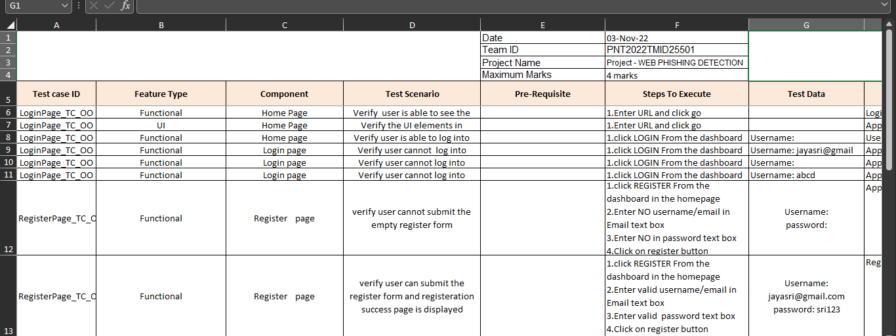
CHAPTER 9 RESULTS

9.1 PERFORMANCE METRICS

- Hours worked: 50 hours

- Stick to Timelines: 100%

- Stay within budget: 100%

- Consistency of the product: 85%

- Efficiency of the product: 85%

- Quality of the product: 80%

CHAPTER 10 ADVANTAGES & DISADVANTAGES
ADVANTAGES:

Smooth User Interface
Accuracy is achieved quickly

DISADVANTAGES:

Random forest can be used for both classification and regression tasks, but it is not more suitable for Regression tasks.

CHAPTER 11CONCLUSION
This paper aims to enhance the detection method to detect phishing
Maching learning technology. We achieved 97.14% detection accuracy using random forest algorithm with lowest false positive rate. Also result shows that classifiers give better performance when we used more data as training data.

CHAPTER 12 FUTURE SCOPE
Phishing is considerable problem differs from the other security threats such as intrusions and which as differs in malware based on the technical security holes of the network system.

CHAPTER 13 APPENDIX
PROJECT DEMONSTRATION LINK: https://youtu.be/mnNkPE5JoMY

GITHUB LINK: https://github.com/IBM-EPBL/IBM-Project-26570-1660029758

